**A briefing on Community Prioritization Method**

This is a 2-stage process

* State selection
* LGA selection

For the state selection the criteria are:

**Literacy**: this is considered as an integral part of the process; this measures the competency of the population to comprehend the message being passed across i.e. how easily SHIFT can communicate with the domiciles.

* General literacy
* English literacy

The rating was extracted from NBS (National bureau of Statistics) national literacy survey.

**Digital literacy**: digital inclination is factored in by using Facebook user data across the states of the federation.

**Age Group**: age bracket 20 -50 was considered since these are considered to be most active during voter’s exercise *Extracted from the national population Council projection (2018)*.

**Voters Turnout**: The Election stat of the recently concluded election (presidential and governors) was used to estimate the turnout in the States.

**Candidacy**: the number of political seats/reps in a state would be directly proportional to the number of aspirants or candidates present in such state as the case maybe.

The figure below shows the South South Zone as an example

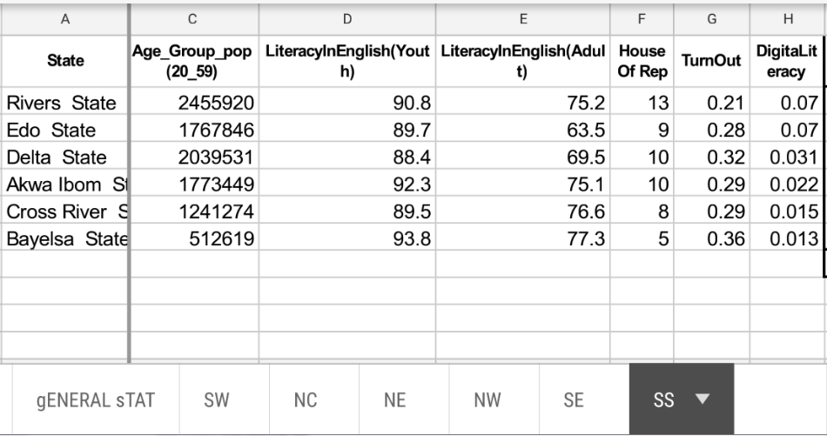

The National level numbers was turned into zonal stat here

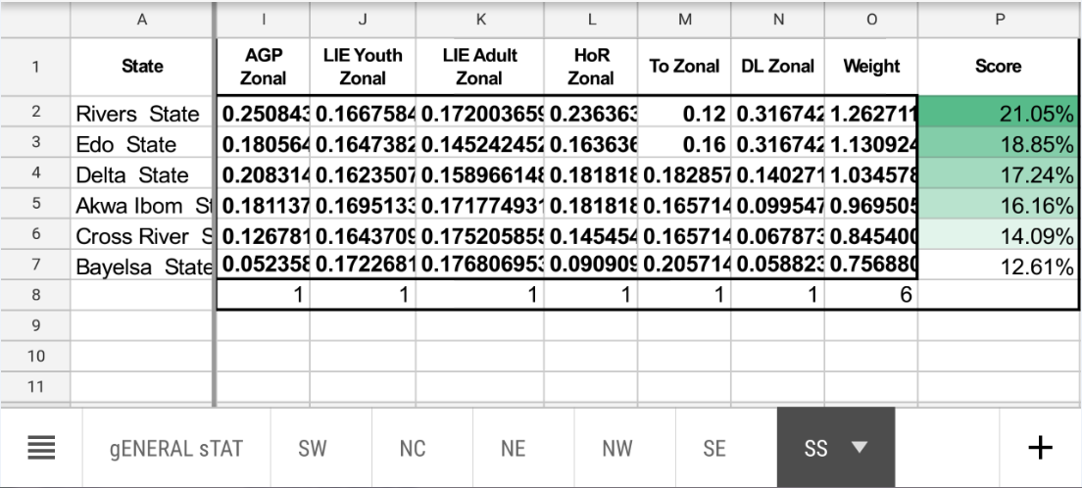

***AGP*** *- Age group population (20-50)*

***LIE*** *-Literacy in English*

***HoR*** *- House Of Rep Members*

***TO***  *– TurnOut(Voters)*

***DL*** *-Digital Literacy*

These are the five factors considered (culled from the available National Statistics), in addition; for every geo-political zone the 2 states with the highest overall score was selected as listed below

*South West- Lagos, Oyo*

*South South – Rivers , Edo*

*South East – Anambra, Imo*

*North East – Adamawa, Taraba*

*North Central- Benue, Plateau*

*North West- Kano and Kaduna*

**LGA selection method**

From the first selections, there are 12 States prioritized. For the LGA prioritized we have fewer criteria used. Such important variables as integral to SHIFT strategy was not available. Factors such as digital literacy was not included while some state election stats at local government level were not included.

Notwithstanding, variable used for these are **volunteer base**, **age group population** and **voters turn out** (all stats are LGA level).

The image below cites Plateau state as an example

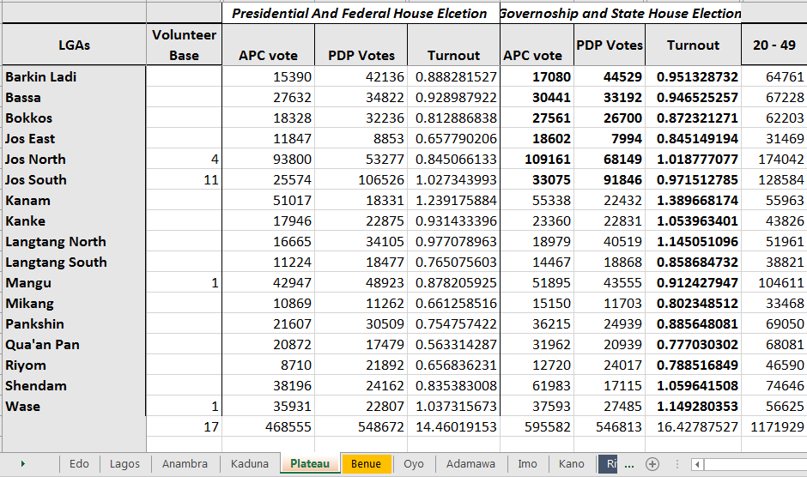

Where

* **Volunteer base** shows the number of SHIFT representatives present in each local government the number of volunteers in LGA was considered as this will ease program execution on the long run.
* **Voters turnout** (Fed and state) are considered, these are estimated turnout for each LGA based on the *[(APC + PDP)/Age group (20-50)]*, with some few Assumptions.
  + *Assumption 1*: other parties votes are quite negligible or Say PDP and APC are the only parties voted for
  + *Assumption 2*: say from (1) , all voters are between the bracket 20-49 age group
* **Age group**: this is the estimated number of people between the age bracket 20 -49 in the LGA.

Here is the 2nd step, for the conversion of the stat to a weighted value in order to be scored.

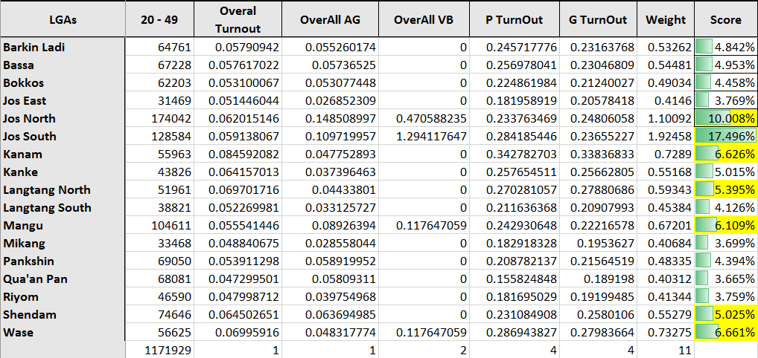

*P TurnOut -Fed Election Turnout with 4 unit point*

*G TurnOut – State Election TurnOut 4 unit-point*

*Overall VB – Volunteer base with 2 unit-point*

*Overall AG -Age group with a unit point*

*Weight – Summation of the variables with a total 11 points*

*Score – with a total of 100%*

Conclusion

From the whole process as listed out, at least 5-Top rated LGAs from each prioritized state are selected based on their score.